# Project Report Template

# INTRODUCTION:

* 1. **Overview**

Vehicle Management System is proposed with the intention of upgrading the current stand alone system to a web based or online system. Proposed to smoothen the management process of the vehicle in order to handle the registration and scrapping it. This stand alone concept to web based system, it helps staffs to store and manage data efficiently and in more organized manner. System also accept information about the accident report, so that none of the accident goes unattained.

* 1. **Purpose**

A vehicle management system is a software system or platform that serves to manage commercial fleets of vehicles, such as cars, vans or trucks or even heavy equipment to ensure they are utilized safely, efficiently and professionally, while making sure they are well maintained and high performing.

# 2.Problem Definition and Design Thinking:-

# 2.1 Empathy Map:

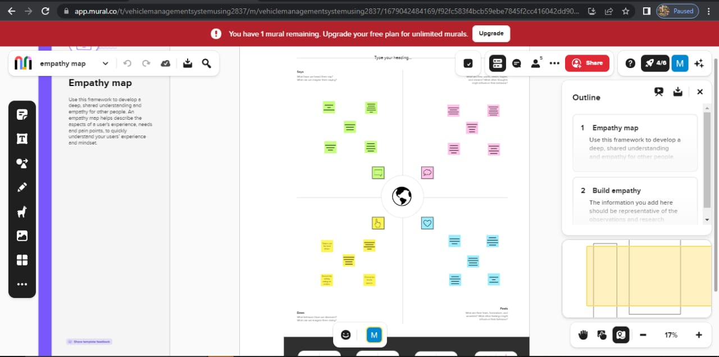

# 2.2 Ideation and Brainstorming map screenshot:

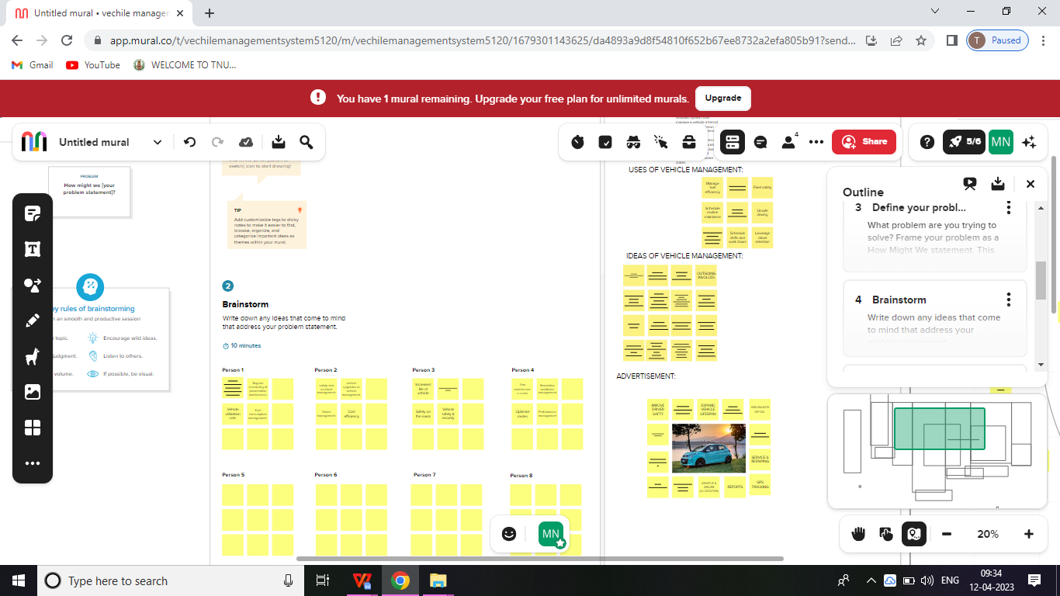

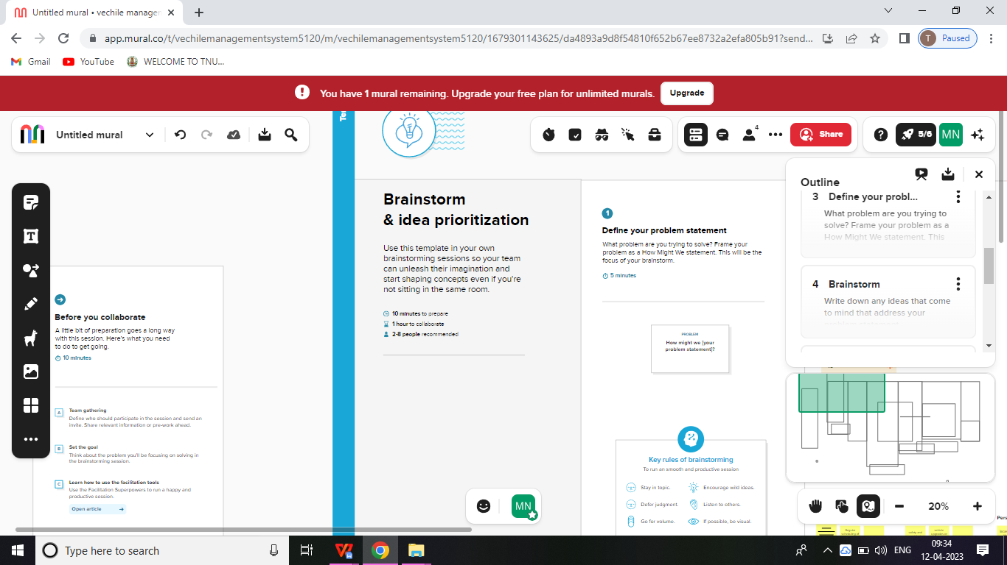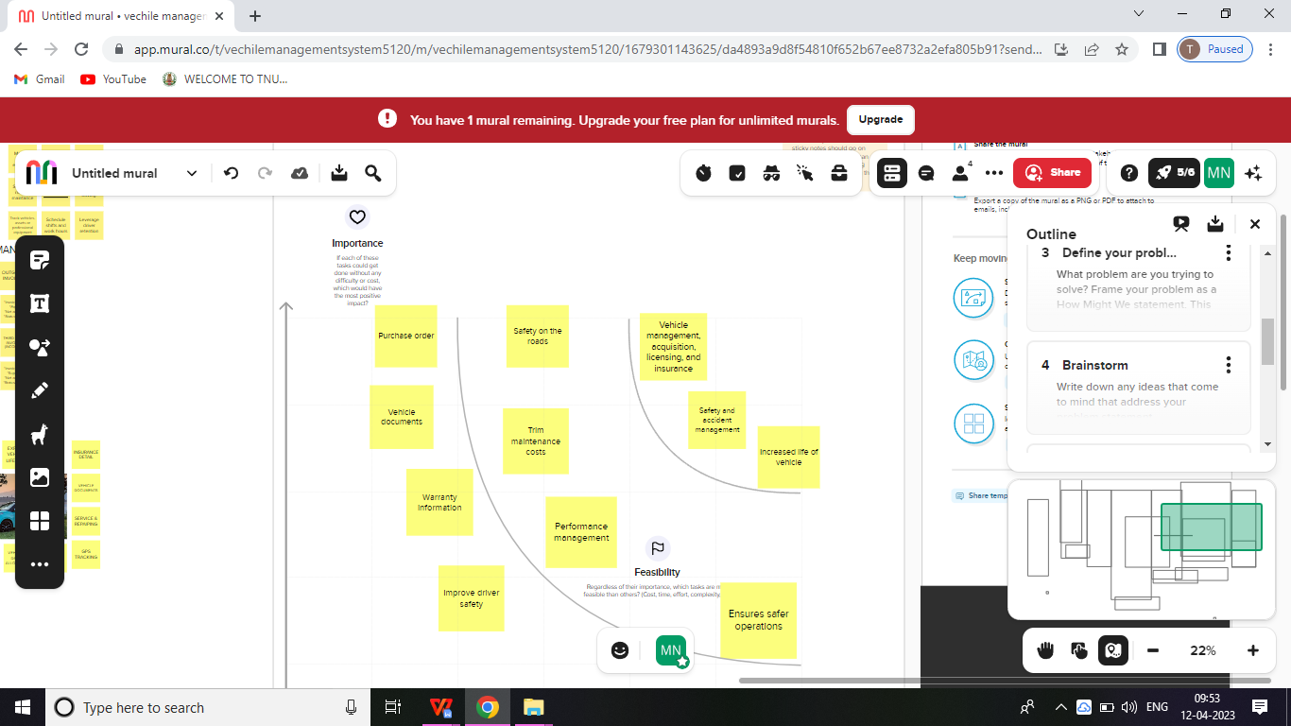

# 3.Result:

**3.1.DATA MODEL :**

|  |  |
| --- | --- |
| Object name | Fields in the object |
| Object-1 | Field Label: vehicle Data type:Text |
| Object-2 | Field Label:VanData type:picklist |
| Object-3 | Field Label: carData type:Text |

**3.2.ACTIVITY AND SCREENSHOT:**

**Create Salesforce org-creating Developer Account**

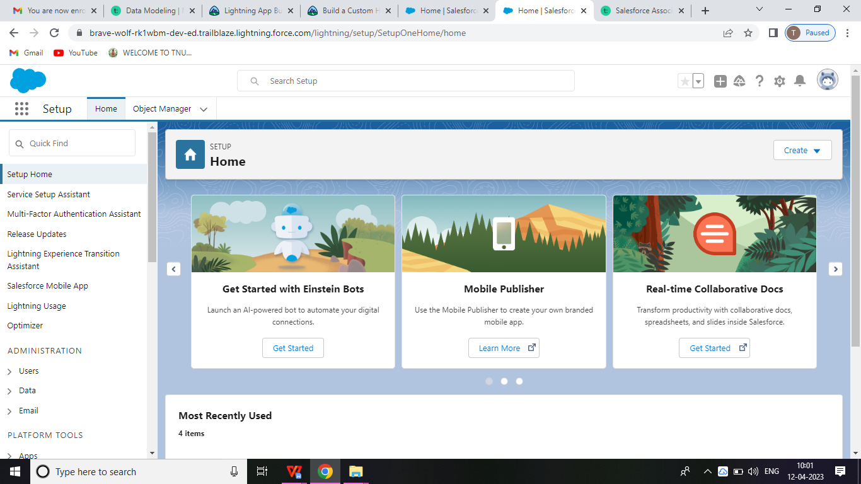

# Object:-

# Creation of car object

# 

# Creation of Vehicle object

# 

# Creation of Van object

# 

# Lighting App

# Create of sales app

# Screenshot (8)Field and Relationship

# Creation Field for Account objects

# 

# Creation of the fields for customers object

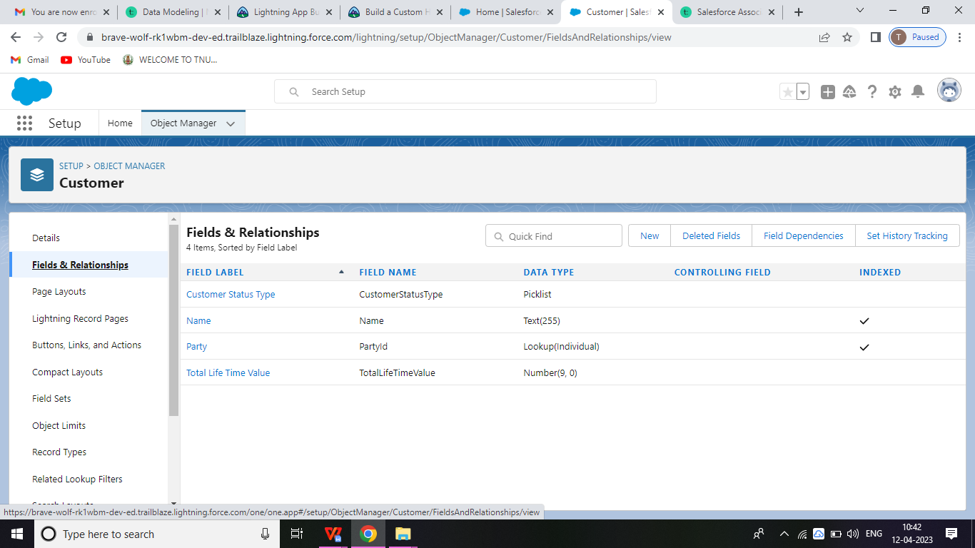**Profile**

# Creation on profile

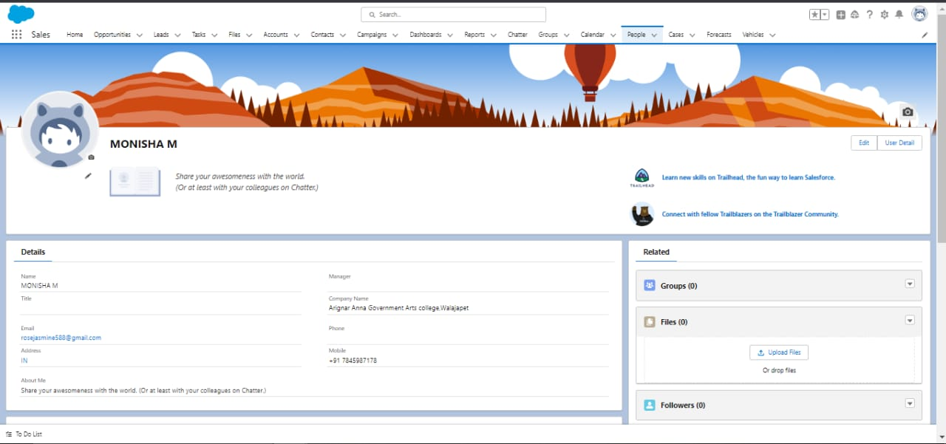

# Users

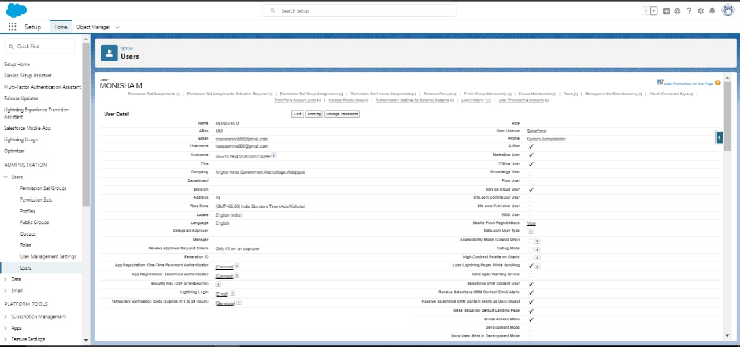

**Permission sets**

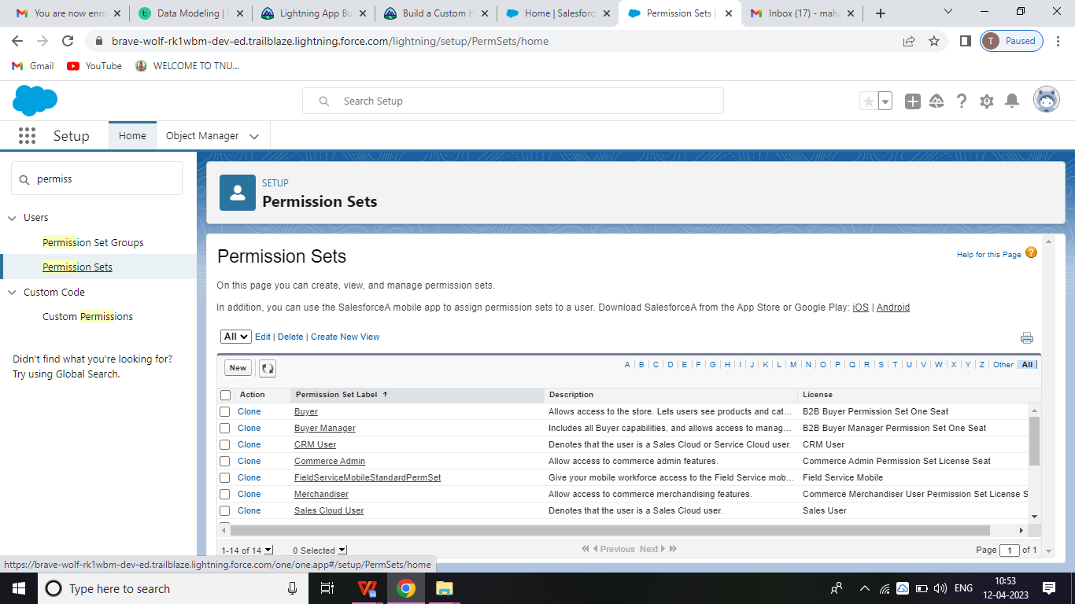

# Reports

# 4.Trail head profile public URL

**TEAM LEAD – https://trailblazer.me/id/mmonisha17**

**TEAM MEMBER 1 – https://trailblazer.me/id/pvenkatraman7**

**TEAM MEMBER 2 – https://trailblazer.me/id/ppreethiba**

**TEAM MEMBER 3 – https://trailblazer.me/id/povel**

# 5.ADVANTAGES & DISADVANTAGES

##### There is a reason why fleet management software systems have made their way into all significant fleet managers’ offices, right? In this section, let us look at some advantages that you are likely to see while using fleet management software systems:

##### Real-time Tracking: [Real-time tracking](https://trackobit.com/blog/what-is-consignment-and-asset-tracking/) is essential for any fleet manager. It is only through live vehicle tracking that managers can rest assured about their [consignment and asset](https://trackobit.com/asset-tracking-management-software) safety and can enjoy features such as route mapping, route planning, driver behaviour analysis, and even concise reports.

##### Automated Operations: Fleet management software solutions help automate end-to-end functions in your fleet. Gone are the days when you had to sit down with paper and pen to make calculations, strategies, and much more.

##### Low Operational Costs: [Fuel monitoring](https://trackobit.com/fuel-management-monitoring-software) and [route planning](https://trackobit.com/tour-route-planning-software) features help reduce operational costs in an organization. You will learn how to use the least possible resources without compromising on results.

##### Higher Profitability: The lower the operational costs in an organization, the higher the profits. Moreover, fleet management software solutions allow you to gain higher profits as you get a clearer insight into how your fleet works and get to understand better operational strategies.

##### Better Security: As long as your fleet management software solution comes with adequate hardware integration, it offers higher security with features such as parking mode, SOS alarms, and immobilization. Security features cover not only consignment but also your vehicles and drivers!

##### Data Analytics: Data analytics is how you can make your business grow exponentially in the future with the information you collect today. You can go beyond vehicle tracking and understand nitty-gritty metrics such as the areas your trucks mostly go through, the most theft-prone areas in your route, and even the best vehicles in your fleet.

* Till now, using fleet management software systems feels like an obvious and ideal choice, right? Well, in most regards, it is. However, it does come with some disadvantages as well:
* Learning Curve: As with all software systems, fleet management software also comes with a certain learning curve. Some systems can be so complicated that without aid from the software provider, you might not unlock the true potential of the tool at hand.
* Extra Cost: Sure, you are bound to gain a lot from using a fleet management software system. The profits you’ll make due to the software aid will eventually make up for the initial subscription cost. However, if you are a small business owner, the initial cost might seem like too much.
* Infrastructure Needs: You’ll face issues using fleet management software systems if you don’t have proper network infrastructure. Without a stable Internet connection at all times, you will be missing out on the ‘real-time’ aspect of these systems. However, you can hardly do anything effectively without proper network infrastructure anyway.
* Resistance From Staff: At least initially, your staff might resist adopting fleet management software systems because they will be under complete surveillance. However, once you explain the [benefits they get from automation](https://trackobit.com/driver-behaviour-monitoring-tracking-software#:~:text=Through insightful reports, TrackoBit will,, overspeeding, and harsh acceleration.), the integration process should become smoother.

**6.APPLICATION:**

Vehicle management systems created by SCAND are desinged to help our clients to keep track of the vehicles in real-time, plan, execute, and optimize their transportation process through GPS and data collections.

* Fleet management app development.
* Vehicle management system customization.
* Vehicle fleet management system integration.

**VEHICLE TRACKING SYSTEM:**

We also provide the development of Scalable and effective software solutions for tracking the vehicles in real-time, optimizing the route in accordance with the weather weather conditions and traffic situations, planning future trips.

**VEHICLE FUEL TRACKING SYSTEMS**

Our software engineers create robust solutions for cost-effective and accurate management of fuel. Such type of software allows avoiding fuel shortage, optimizing the budget, and improving trip planning.

**VEHICLE MAINTANENCE SOFTWARE SOLUTIONS**

Solutions for tracking the vehicles condition and preventing serious breakdowns by planning the requires maintenance manipulations in advance.

**VEHICLE TRACKING SYSTEMS**

We also provide the development of scalable and effective software solutions for tracking the vehicles in real-time, optimizing the route in accordance with the weather conditions, and traffic situations, planning future trips.

1. **FUTURE SCOPE:**

In this modern age, many people have vehicles. Vehicle is now a basic need. Every place is under the process of urbanization. There are many places where people used to go for refreshment. So all these place needed a parking space where people can park their vehicles safely and easily.

Every parking area needs a system that records the detail of vehicles to give the facility. These systems might be computerized or non-computerized. With the help of computerized system we can deliver a good service to customer who.

Wants to park their vehicle into the any organizations premises.

**7.CONCLUSION:**

Our project is only a humble venture to satisfy the needs to manage there project work. Several user friendly coding have also adopted. This package shall through to be a powerful package in satisfy all the requirements of the school. The objectives of software planning is to provide a frame work that enables the manager to make reasonable estimates made within a limited type frame at the beginning of the software project and should be updated regularly has the project process.

Getting the land in metropolitan cities other higher order cities for parking space is proving infeasible. The solution for the parking requirements is the multi-level car parking systems to maximize car parking capacity by utilizing vertical space rather than expanding horizontally.

Use this project for individual purpose in a wide range. The accuracy of this project may be improved by adding some features.